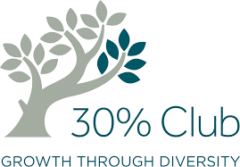

DEC 2015
1. | The New Straits Times (Advertorial on Women Director Sourcing Service by NIEW) | 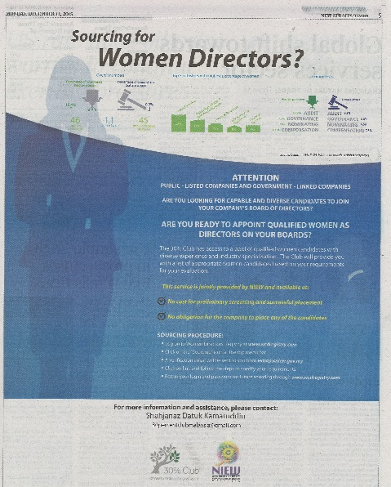

NOV 2015
1. | Forbes | On Women And Leadership: Three Amazing Asian Stories

OCT 2015
1. | LeadWomen  (Bloomberg TV Malaysia) | Women Talent Supply Sufficient, Demand Now Needed: 30% Club Malaysia

MAY 2015
1. | Malay Mail | PM launches ‘30% Club’ in bid to triple number of women on boards
2. | AESC.org | Launch of 30% Club Malaysia
3. | Focus Malaysia | The next corporate revolution

MAR 2015
1. | Astro Awani | 30% Club Malaysia aims to be the first in ASEAN with 30 pct women on boards
2. | Business Circle | More women to power the boardroom

